Ideation Phase
Empathize & Discover

Date | 19 September 2026
Student ID | 23NU1A4429
Project Name | Automated Network Request Management in ServiceNow
Maximum Marks | 4 Marks

User Empathy Map: Corporate Requester Persona

PS-1: End-User Persona — The Requester

User Context
An enterprise employee who needs a new physical network connection or requires an existing corporate network setup to be relocated or modified during a workplace transition.

Core Objective
To submit accurate network, hardware, requester, and location information through a simple self-service interface and receive timely updates until the request is fulfilled.

1. What Do They SAY?
- "I want a simple Service Portal form to submit my network request."
- "I don't want to enter my personal information repeatedly when ServiceNow already has it."
- "I need my REQ and RITM numbers after submitting the request."
- "I want to know whether my request has been approved and assigned."
- "I need confirmation that the information I submitted reached the IT/network team correctly."
- "I want to receive a notification when my request is completed."

2. What Do They DO?
- Opens the ServiceNow Service Portal.
- Searches for the Network Request catalog item.
- Enters the required network and service information.
- Selects or provides requester details.
- Submits the request.
- Receives the generated REQ/RITM information.
- Waits for approval and fulfillment.
- Checks the request status for progress.
- Contacts the support team if the status or progress is unclear.

3. What Do They THINK?
- "Did my request get submitted successfully?"
- "Are my requester details populated correctly?"
- "Will my Network Database and Network Task records be created automatically?"
- "Has my request been approved?"
- "Who is handling my request?"
- "Is the information I entered being transferred correctly?"
- "When will my request be completed?"

4. What Do They FEEL?
- Frustrated: When information must be entered repeatedly.
- Confused: When the form contains unnecessary or unclear fields.
- Uncertain: When approval and fulfillment progress cannot be easily understood.
- Concerned: That incorrect information may delay the request.
- Relieved: When information is automatically populated and records are created correctly.
- Confident: When the request lifecycle is transparent and automated.

5. PAINS — Systemic Friction Points

Manual Data Entry
Repeatedly entering requester and service information increases effort and the possibility of errors.

Complex Request Form
A non-contextual form can make it difficult for users to understand which information is actually required.

Limited Visibility
The requester may not clearly understand the current approval, assignment, or fulfillment stage.

Manual Follow-up
Users may need to contact IT/network teams to obtain updates.

Record Creation Uncertainty
Users have no direct visibility into whether the corresponding operational records have been created and processed correctly.

6. GAINS — Target-State Expectations

Simple Self-Service Experience
A centralized ServiceNow Service Portal provides a structured interface for submitting network requests.

Automatic User Information
Available requester information can be automatically populated instead of repeatedly entered.

Automated Record Creation
Submitted catalog information can automatically generate the corresponding Network Database and Network Task records.

Transparent Lifecycle
The relationship between REQ → RITM → Network Database → Network Task provides better traceability.

Automated Communication
The requester receives appropriate notifications when important lifecycle events occur, including completion.
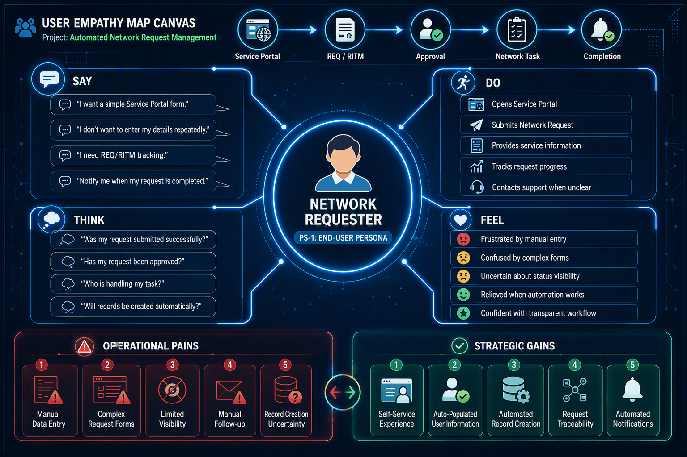

PS-2: Backend Administrator Persona — The Fulfiller

User Context
An IT Network Infrastructure Administrator responsible for validating network requirements, coordinating fulfillment, maintaining network records, and ensuring accurate processing of infrastructure requests.

Core Objective
To receive complete and accurate request information, process network requests efficiently, and maintain consistent operational records throughout fulfillment.

1. What Do They SAY?
- "I need complete request information before beginning fulfillment."
- "I should not have to manually copy information from the request into another record."
- "The Network Database and Network Task should be created automatically."
- "I need a clear relationship between the original request and the fulfillment task."
- "Approval and assignment should follow a standardized process."
- "I need accurate information throughout the request lifecycle."

2. What Do They DO?
- Reviews incoming network requests.
- Validates the submitted information.
- Checks approval status.
- Reviews Network Database information.
- Processes the generated Network Task.
- Performs or coordinates the required network fulfillment.
- Updates the task work status.
- Tracks the request until completion.
- Provides or triggers completion communication.

3. What Do They THINK?
- "Does the request contain all the information required for fulfillment?"
- "Was the Network Database record created correctly?"
- "Was the Network Task populated with the correct values?"
- "Has the required approval been completed?"
- "Can I trace this task back to the original RITM?"
- "Will manually entered information create inconsistencies?"
- "Can the system automate these repetitive activities?"

4. What Do They FEEL?
- Overwhelmed: When multiple requests require repetitive administrative activities.
- Concerned: When submitted information is incomplete or inconsistent.
- Frustrated: When records must be manually created or information copied repeatedly.
- Anxious: When errors can affect network fulfillment or record accuracy.
- Relieved: When required records and information are automatically generated.
- Confident: When the workflow provides accurate, traceable, and standardized information.

PAINS — Systemic Friction Points

Incomplete Request Information
Missing network or requester information can require additional clarification.

Manual Record Creation
Creating Network Database and Network Task records manually increases administrative effort.

Repeated Data Transfer
Copying catalog information into operational records can introduce inconsistencies.

Approval Bottlenecks
Manual approval coordination can delay fulfillment.

Limited Traceability
Disconnected records make it more difficult to follow the complete relationship between the request and fulfillment activity.

Manual Communication
Providing completion updates manually adds additional workload.

GAINS — Target-State Expectations

Automated Data Mapping
Catalog variables are automatically transferred into the appropriate Network Database and Network Task fields.

Automated Record Creation
The system automatically creates the required operational records after request submission.

Standardized Workflow
Approval, assignment, fulfillment, and status handling follow a consistent ServiceNow process.

Request-to-Task Traceability
The relationship between REQ, RITM, Network Database, and Network Task is maintained throughout the lifecycle.

Reduced Administrative Work
Automation reduces repetitive record creation, data transfer, and manual coordination.

Reliable Requester Communication
Important lifecycle events can trigger automated notifications to the requester.
